26.Design TM using simulator to accept the input string Palindrome bbabb

*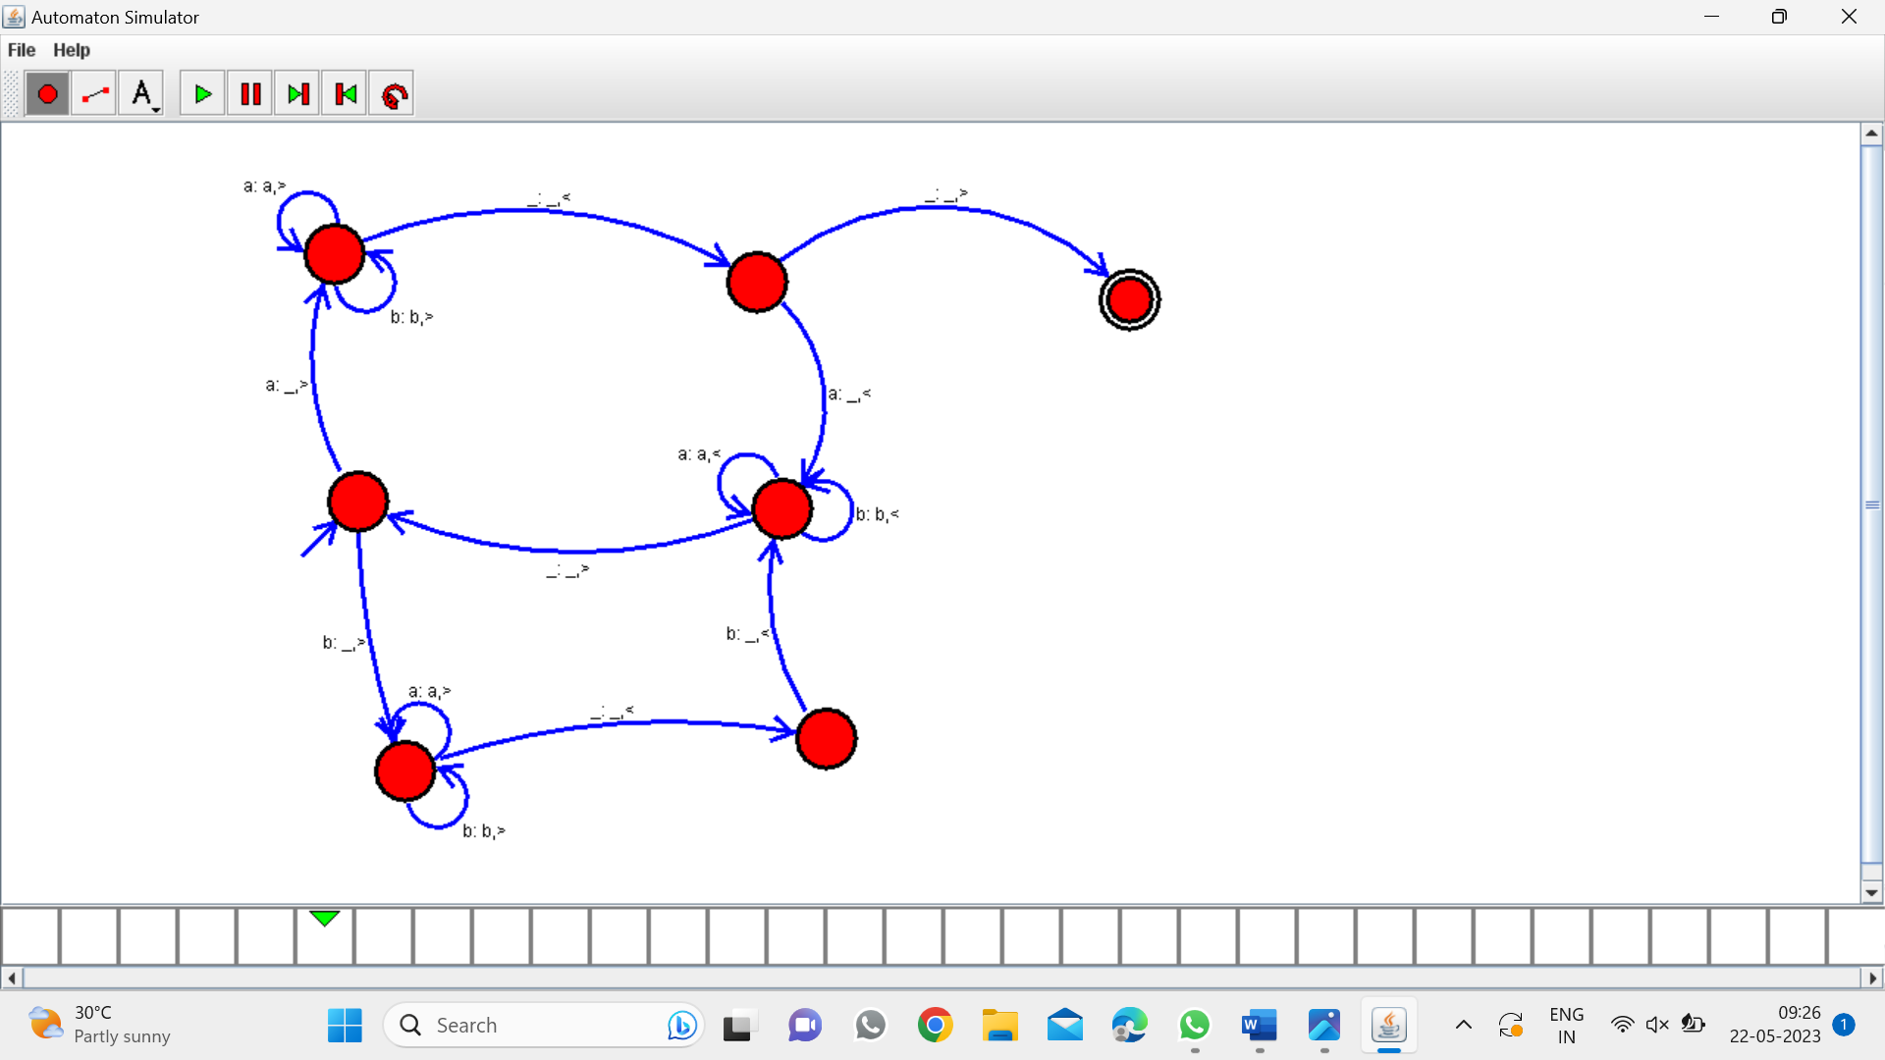*

Result:-

From the above Turing Machine diagram valid the string bbabb